**Achieve this short story with the command line alone.**

*Create your copy of the file and enter your command in the terminal space ($) below each action*

N/B: The story here is fictional and the files are just hypothetical. Please don’t use it for any serious research work.

1. ~~Login to the server~~

|  |
| --- |
| $ |

1. Create a new folder titled your name

|  |
| --- |
| $ mkdir Luisa |

1. Create another new directory titled biocomputing and change to that directory with one line of command

|  |
| --- |
| $ mkdir biocomputing  $ cd biocomputing |

1. Download these 3 files:
   1. <https://raw.githubusercontent.com/josoga2/dataset-repos/main/wildtype.fna>
   2. <https://raw.githubusercontent.com/josoga2/dataset-repos/main/wildtype.gbk>
   3. <https://raw.githubusercontent.com/josoga2/dataset-repos/main/wildtype.gbk>

*Hint: Google search for “command for download file in linux”*

|  |
| --- |
| $ sudo apt-get install wget  $ wget <https://raw.githubusercontent.com/josoga2/dataset-repos/main/wildtype.fna> <https://raw.githubusercontent.com/josoga2/dataset-repos/main/wildtype.gbk> https://raw.githubusercontent.com/josoga2/dataset-repos/main/wildtype.gbk |

wildtype.fna

wildtype.gbk

wildtype.gbk.1

1. OH! You made a mistake. You have to move the .fna file to the folder titled your name directly. (Do this with one command. Hint: [See our cheatsheet](https://cheatography.com/davechild/cheat-sheets/linux-command-line/))

|  |
| --- |
| $ mv wildtype.fna /home/luisacriollo17/Luisa |

1. OH No! The gbk file is a duplicate, they are actually the same thing. Please delete it.

|  |
| --- |
| $ rm wildtype.gbk.1 |

1. The .fna file is actually from a bacteria, and it should definitely have a TATA (tata) box for initiating gene transcription. The molecular biologist is trying to understand the implication of dual TATA sequences. The files got mixed up and we are not sure which is wildtype and which is mutant. The mutant should have “tatatata” while the normal should have just “tata”. Can you confirm if the file is mutant or wild type

|  |
| --- |
| $ cd ~  $ cd Luisa  $ grep "tatatata" wildtype.fna |

1. If it is mutant, print all the lines that show it is a mutant into a new file

|  |
| --- |
| $ grep "tatatata" wildtype.fna > mutant.fna |

1. Clear your terminal space and print all the commands you have used today.

|  |
| --- |
| $ clear  $ history |

1. List the files in the two folders and share a screenshot of your terminal below

|  |
| --- |
| $ ls biocomputing Luisa |

Your pictures go here:

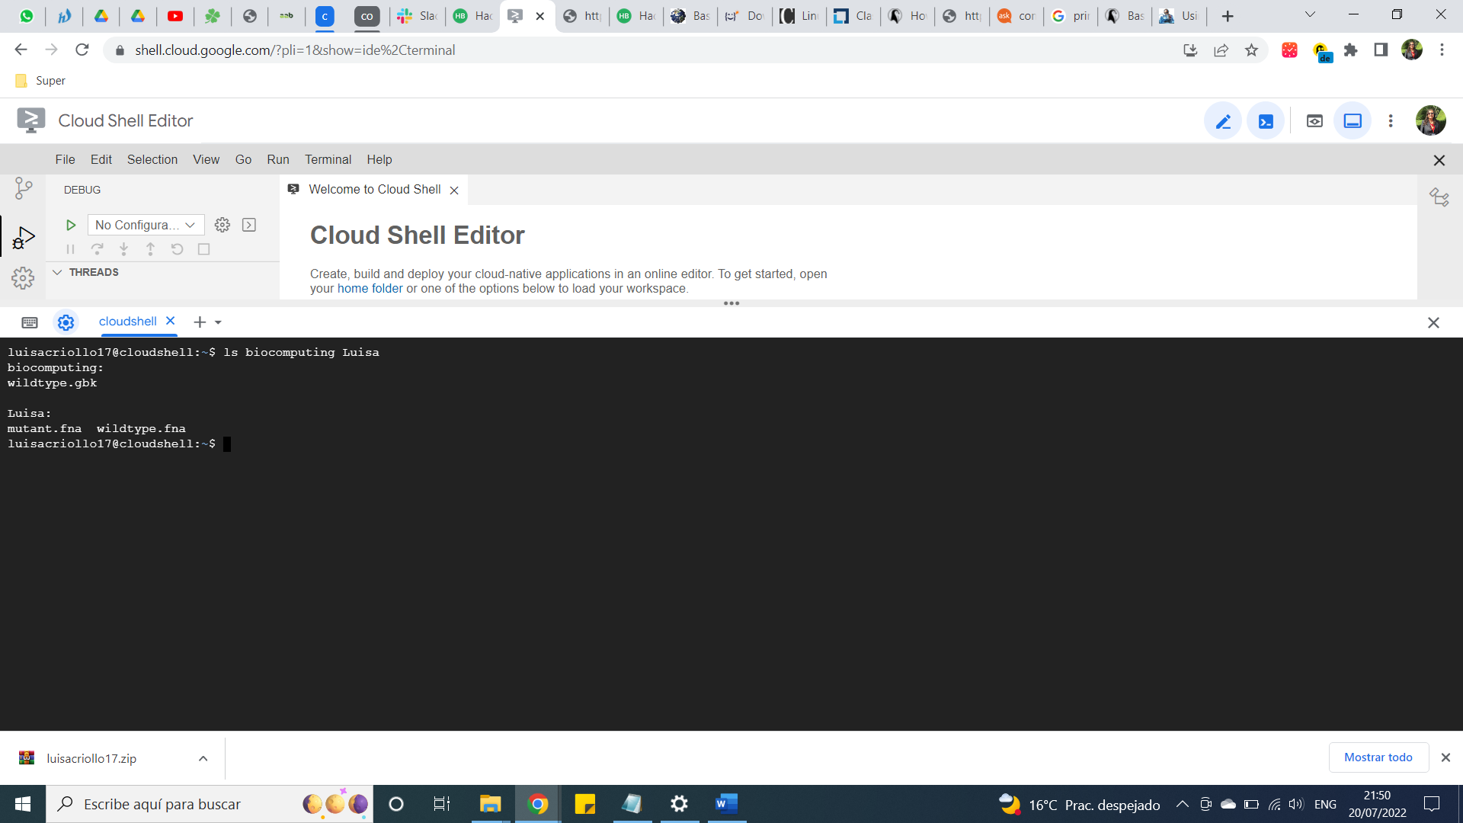

**Bonus Task: Exit the terminal**

|  |
| --- |
| $ exit |